Project Name: F&P Perfumes

Full name: Muhammad Ibrahim

Student ID: 35533927

Tutor Name: Hena Iqbal

Unit Code: ICT 1711

Unit Name: Introduction to Server Environment and Architecture

DNS: <https://fpperfume.online>

IP address: 13.60.210.153

Introduction:

My project is F&P Perfumes, it is an e-commerce website for my perfume business, which can be visited using this link <https://fpperfume.online> . The purpose of this website is to market perfume products, provide comprehensive descriptions, and include an e-commerce component to facilitate the buying process. In addition, the website will also include customer ratings, an information blog, and a newsletter subscription to foster interaction among users and build a base of loyal customers. The project utilizes AWS for hosting, VirtualBox for virtualization, and Ubuntu as the operating system.

Objective:

To create an immersive online destination for fragrance enthusiasts by offering a curated selection of premium perfumes, providing detailed product insights and delivering a seamless shopping experience. Ultimately, deriving brand awareness, customer engagement, and sales conversions.

Set up and configuration:

I choose Amazon Web Services (AWS) to host my server.

**Steps while setting up**

1. Log in to console: Go to AWS Management Console and login in using your cresidentials.
2. Launch an EC2 Instance:

Search EC2 after logging in to AWS Management Console and select EC2 services.

Then select the launch Instance option from the EC2 Dashboard.

Choose Ubuntu in AMI options

Select t3.micro instance type which is within the free tier.

Enable both HTTPs ports and SSH port for traffic.

Creating a key pair name , in my case fpperfumes.

Launch Instance.

1. Make your IP address Static:

Go to EC2 dashboard and select Elastic IPs.

Then select your IP address and allocate.

Then associate it with your virtual machine.

1. Connect to your Instance:

By using your IP address, connect to your instance and establish an SSH connection.

🡨 click connect

1. Install Web server and check if it works by using public IP:



Apache2 is running successfully.

1. Install Database Server:





1. Change MySQL authentication







1. Create User to work on WordPress:





1. Create a new database for WordPress



1. Assign all privileges to the user:



1. Install WordPress and extract file

1. Copy the extracted file to the Apache web root:

1. Open IP with WordPress and Launch WordPress

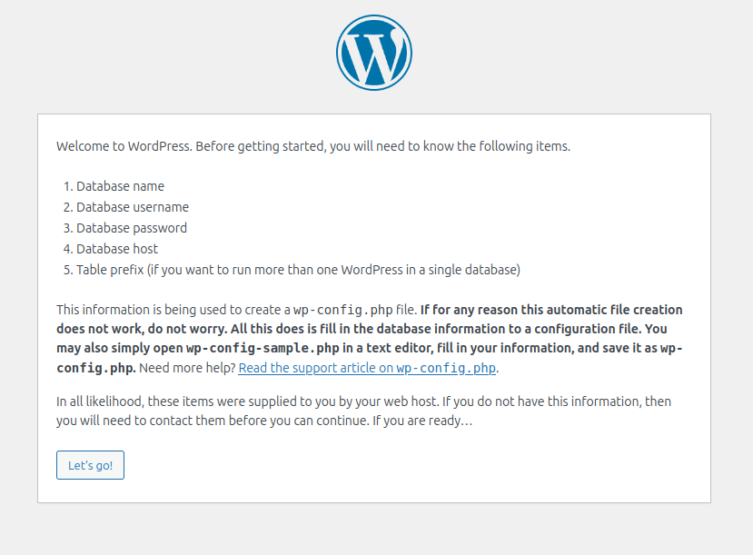

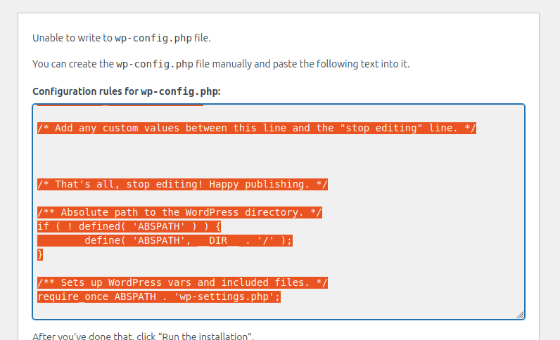

Upon showing error go to the terminal and change directory to wordpress and copy paste code there



And then Run Installation

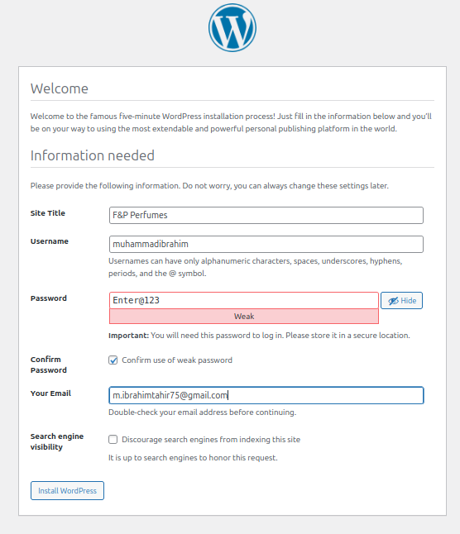



1. Edit file default to directly link wordpress

Restart Apache

1. Purchase a Domain from Godaddy

1. Go to DNS and add a record to connect your public IP to your domain

🡨 save

1. Modify the configuration and restart Apache

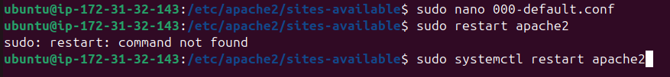

1. Add SSL certificate to secure the Website

